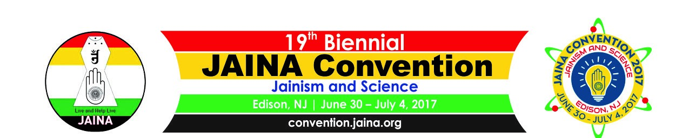

Guidelines for JAINS Got Talent Program
JAINA Convention 2017

Following are the guidelines specific to “Jains Got Talent”, created by the 2017 JAINA Convention Program Planning Committee on behalf of JAINA:
Guidelines:
- There will be three categories based on age and number of participants registered within age group:
Group 1: Age 17 years and under
Group 2: Age 18 to 34 years
Group 3: Age 35 years and above

Jains Got Talent participant/s registration needs to be very clear as to which group they are participating in and age/DOB of each individuals competing in the solo or group act should be listed

- Competition will be between the contestants of the same category.
- Contestants can choose between submitting a solo act or a group act, but must stay consistent throughout all stages (audition, preliminary rounds, grand finale)
- The theme for JAINA is “Jainism & Science”. While it is not necessary to incorporate the theme in the performance, it would be appreciated if the acts can incorporate this theme in their performances. While you are able to use songs from movies or any particular act, please use your best judgment to determine which songs/dances/acts are appropriate for a JAINA Convention.
- The order of acts will be finalized by the Convention Program Committee once all presentation details are known.
- For any act that requires putting of Bhagwan’s or Dev/Devi’s statue/photo on stage, no footwear will be allowed (on the stage).
How to apply:
Registration Form and guidelines can be downloaded from Convention Web site
at http://convention.jaina.org under Program Information section, Jains Got Talent.
Interested individuals should submit an audition video (no more than 5 minutes long) or web link of YouTube clip displaying their talent either by mail addressed to JAINA Convention (Jains Got Talent), C/O Jayesh Sanghvi 3510 Maverly Crest Court, Katy, TX 77494 or email to both email addresses: jaingottalent@jaina.org, and Convener2017@jaina.org, The audition video/link and registration form must be received by April 2, 2017.
The deadline for receipt of the application form and the audition materials is April 2, 2017.
Signed registration forms with complete details and video consent form (legible/readable clearly) can be scanned and sent to us at jaingottalent@jaina.org, and Convener2017@jaina.org by deadline.
Audition Process:
- The audition video should not exceed 5 minutes and should display the talent you wish to show. Examples of talent include but are not limited to: dancing, singing, playing a musical instrument, acting, magician, etc.
- The JAINS Got Talent Program Planning Committee will select a panel of judges who will provide initial screening of the acts. Successful participants will be notified by May 7, 2017 and will be invited for further participation in the competition at the convention.
Competition process at the Convention:
- There will be 3 rounds of performances at the Convention.
  - Round 1 – Friday early afternoon (June 30, 2017)
  - Round 2 (only if needed) – Friday late afternoon (June 30, 2017)
  - Grand Finale on Stage – Saturday/Sunday evening (July 1 & 2, 2017)
The first and second rounds will be judged by a panel of judges. Successful participants in these rounds will move to Grand finale. Judging in the Grand finale round will be by the judges and the audience! Winners will be announced on Monday July 3rd during the evening program.

Please note: Anytime there is a tie in contest, Judges will make final decision.

JAINA reserves the right to change timing of each round.
JAINA also reserves the right to merge groups based on the number of entries received.

